H.T No
Regulations:
A15


Sreenidhi Institute of Science and Technology
(An Autonomous Institution)
Code No: 5C408 Date: 01-Dec-2018 (AN)

B.Tech II-Year II-Semester External Examination, Nov/Dec - 2018 (Supplementary)
Electronic Circuit Analysis (ECE)

Time: 3 Hours Max.Marks:75

Note: a) No additional answer sheets will be provided.
b) All sub-parts of a question must be answered at one place only, otherwise it will not be valued.
c) Missing data can be assumed suitably.

Part - A Max.Marks:25

Answer all QUESTIONS.

1. | What are the advantages of Multi stage amplifiers. | [3M]
2. | What are the advantages of differential amplifiers. | [3M]
3. | What are the conditions for producing sustained oscillations. | [3M]
4. | Define conversion efficiency. | [3M]
5. | What is the difference between single tuned capacitive coupled and single tuned transformer coupled amplifier. | [3M]
6. | A DC voltage supply provides 60V when the output is unloaded when connected to a load the output drops to 56V. Calculate voltage regulation. | [2M]
7. | List out any two differences between enhancement and depletion type MOSFET's. | [2M]
8. | List any two applications of tuned amplifiers. | [2M]
9. | Why efficiency is very low in class A power amplifier. | [2M]
10. | How to reduce miller effect in tuned amplifiers. | [2M]
Part – B Max.Marks:50
ANSWER ANY FIVE QUESTIONS. EACH QUESTION CARRIES 10 MARKS.

11. | a) | Explain the small signal operation of Darlington pair Amplifier. | [5M]
 | b) | For the loaded emitter follower configuration of the below figure with a source resistance and no load two port parameters of Z_{i}=157.54KΩ, Z_{o}=21.6Ω, A_{vNL}=0.993 with r_{e}= 21.74Ω and β =65  (i) Determine the new values of Z_{i ,} Z_{o,} as determined by the load and R_{s} respectively.  (ii) Voltage gain (A_{v}) ,Voltage gain (A_{vs}) , Current gain (A_{i})  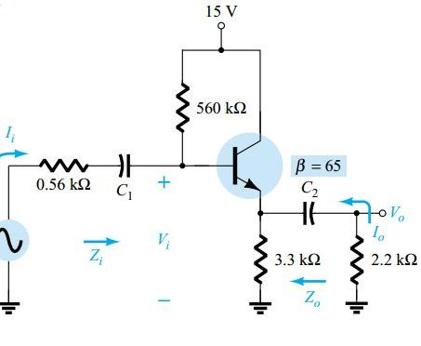 | [5M]
12. | a) | Explain the small signal analysis of a MOSFET Common Source amplifier  provided with Voltage divider biasing network. | [5M]
 | b) | Design the fixed bias network of the below figure with an AC gain of 10. Determine its R_{D} value.  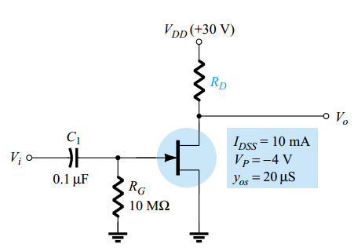 | [5M]
13. | a) | Explain the operation of RC phase shift oscillator and derive the expression for frequency of oscillations. | [5M]
 | b) | Compare different types of feedback amplifiers. | [5M]
14. | a) | Explain the operation of Class A power amplifier and calculate its maximum efficiency. | [5M]
 | b) | Calculate input power, output power and efficiency of the power amplifier in below figure for an input voltage that results in base current of 10mA peak  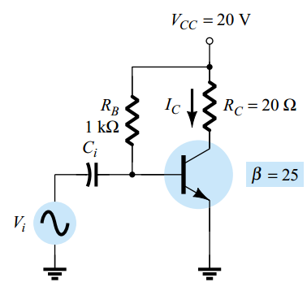 | [5M]
15. | a) | Explain the operation of Single tuned transformer coupled amplifier. | [5M]
 | b) | Discuss about the Wideband tuned amplifiers. | [5M]
16. | a) | Explain the basic working concept of SMPS. | [5M]
 | b) | Explain the basic operation of UPS. | [5M]
17. | a) | Compare different types of Oscillators. | [5M]
 | b) | Explain the small signal operation of Differential Amplifier. | [5M]
18. | a) | Explain about the classification of power amplifiers. | [5M]
 | b) | Explain the block diagram of IC723. | [5M]

-- 00 -- 00 –

